Home Staging:

Hi Mr. Hunna Hunna!

Hope this email finds you well! As your real estate specialist, I just wanted to take a moment to share a few quick statistics about the value of home staging when it comes time to sell a home.

Did you know…
- 85% of staged homes sold for 6-25% more than un-staged homes
- 77% percent of buyers' agents said staging a home made it easier for a buyer to visualize the property as a future home?
- With a spend of just .5% of the sales price MORE on the staging services, sellers saw at least a 6% price difference

It’s for these reasons and more that I offer professional home staging on all of my listings. If you’d like to learn more about what it takes to sell or even how much your home is worth in today’s market – call or text me today. I’m happy to be that resource for you!

Keep smiling!

Darryl Davis

P.S. – A picture is worth a thousand words – and sometimes thousands of dollars. Ensure that your home is seen in the most favorable light possible. Take a look at the attached photographs to see what a difference home staging can make!

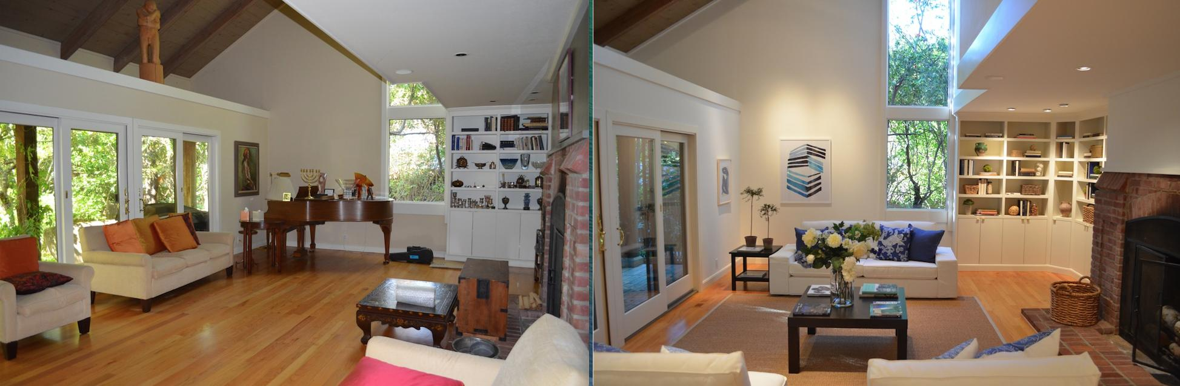

*Agents, please replace with your own photo samples.

