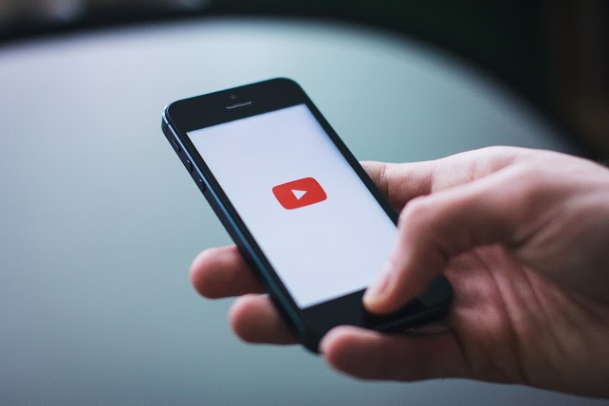**APPS FOR VIDEO/VIRTUAL DELIVERY**

* [GoToMeeting:](https://www.gotomeeting.com/) Different from GoToWebinar, it is great to use for a small group of people so you can all see each other.
* [Zoom Meetings:](https://zoom.us/meetings) Conference style, where everyone can show their faces and speak. Great for smaller groups.
* [FaceTime:](https://apps.apple.com/us/app/facetime/id1110145091) A great way to stay connected and speak to clients, family, and friends!
* [Facebook Live:](https://www.facebook.com/facebookmedia/solutions/facebook-live) Another great way to share messages with the world - video will be a key influencer during these times.

**HARDWARE NECESSARY FOR HOME STUDIOS**

* **Camera:** I found several suggestions on Amazon for easy deliverability.
  + - * + [Logitech](https://www.amazon.com/Logitech-Internet-Camera-2-0-Megapixel-Resolution/dp/B000RZQZM0/ref=sr_1_17?crid=2H6ZP9JVDMJBN&keywords=logitech+camera+and+microphone+for+computer&qid=1584983707&sprefix=logitech+camera+and+mic%2Caps%2C179&sr=8-17&swrs=B86B50B89B84EBE8B8EA83AB6DF30974)
        + [Logitech Pro Stream](https://www.amazon.com/Logitech-C922x-Pro-Stream-Webcam/dp/B01LXCDPPK/ref=sr_1_9?crid=2H6ZP9JVDMJBN&keywords=logitech+camera+and+microphone+for+computer&qid=1584983879&sprefix=logitech+camera+and+mic%2Caps%2C179&sr=8-9)
* **Light Kits:** There are kits available via Amazon such as this one that is a good start for lighting and backdrops:
  + - * + [Lighting Kit](https://www.amazon.com/Neewer-Background.../dp/B019GTCNXC)
        + **[Webcam Privacy Cover](https://www.amazon.com/HUYUN-Privacy-Shutter-Protects-Logitech/dp/B01N7B8QIS/ref=sr_1_6?keywords=computer+camera+cover+flap&qid=1584984388&sr=8-6&swrs=0ECF84A614035748BC7BE6612A474D0F)**
* **Microphone:** I found several suggestions on Amazon for easy deliverability.
  + - * + [Yeti Preferred Webinar Mic](https://www.amazon.com/Blue-Yeti-USB-Microphone-Silver/dp/B002VA464S)
        + [Lavalier Mic Preference](https://www.amazon.com/Shure-MVL-Omnidirectional-Microphone-Windscreen/dp/B010W6WESM/ref=as_li_ss_tl?s=musical-instruments&ie=UTF8&qid=1536252158&sr=1-2&keywords=shure+mvl&dpID=31ltILgHMSL&preST=_SY300_QL70_&dpSrc=srch&linkCode=sl1&tag=httpthinktv-20&linkId=3234c52cb4d5e64a37a8118328695dae&language=en_US)

**VIDEO TUTORIALS**

* + - * **[Best Gear for Podcasts](https://www.youtube.com/watch?v=egFX4t1YjGE)**
      * **[Best Lighting for YouTube Videos](https://www.youtube.com/watch?v=wKt0NaMHCbM)**
      * **[Best Video Accessories for Smartphones](https://www.youtube.com/watch?v=ruDJgtcZB-E)**
      * **[How to Edit Video on Your Phone](https://www.youtube.com/watch?v=TGo2EH9xuQ4)**
      * [Justin Brown:](https://www.youtube.com/channel/UCO4Nw0vUpxgb0zsziJ1SaMg)When it comes to video tools, tips, and techniques, Justin seems to be a real expert.

# OTHER USEFUL LINKS

* **[6 Easy Tips for Effective Virtual Meetings](https://www.colinjamesmethod.com.au/6-tips-for-effective-virtual-meetings-while-working-from-home/)**
* **[Coronavirus: A Guide for REALTOR®s from NAR](https://www.nar.realtor/coronavirus-a-guide-for-realtors)**
* **[Coronavirus Resources for Property Owners from NAR](https://www.nar.realtor/coronavirus-resources-for-property-owners)**
* **[Ultimate Guide to Remote Meetings from Slack](https://slackhq.com/ultimate-guide-remote-meetings)**
* **[REALTOR® Magazine Daily News](https://magazine.realtor/daily-news)**
* **[Virtual Meeting Tips from Forbes](https://www.forbes.com/sites/josephliu/2020/03/17/virtual-meeting-tips/#6b7b2e0e7208)**