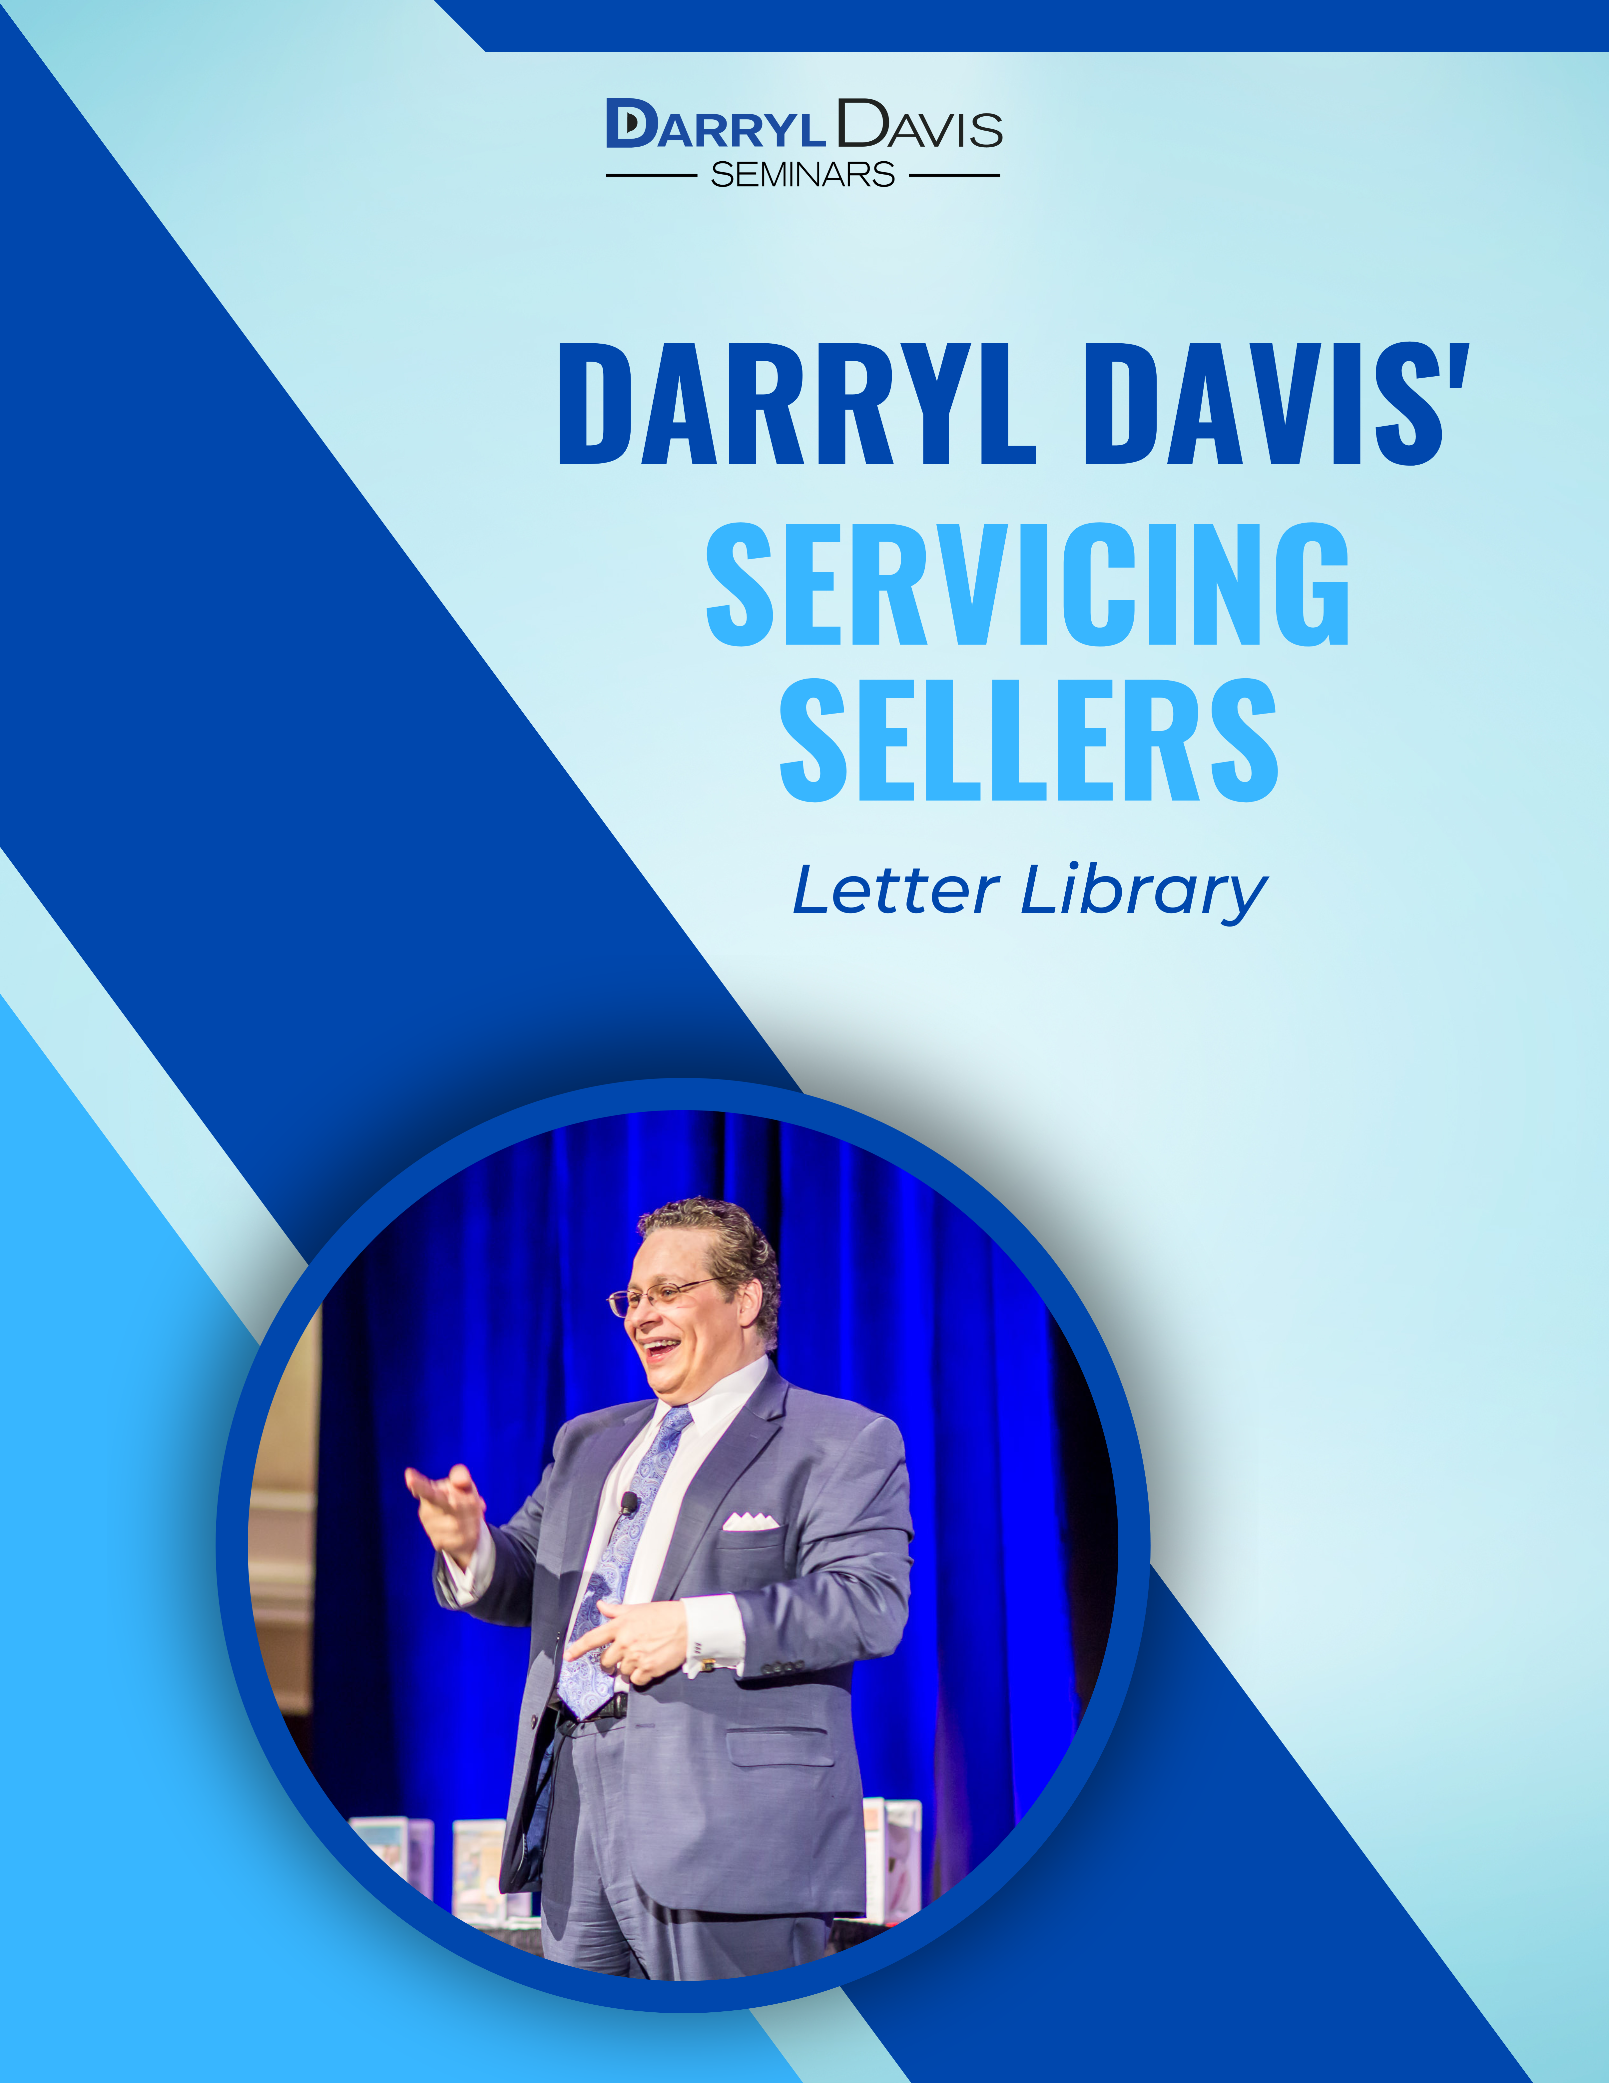
LETTER 1

Dear Lucky,

I would like to take this opportunity to thank you for hiring our office to market your home.

You have placed your trust and confidence in YOUR NAME and I want you to know that you will have the support of our entire team.

Be assured that we are totally committed to do whatever is in your best interest until your property is SOLD.

Sincerely,

DARRYL DAVIS

LETTER 2

Dear Lucky,

I would like to take this opportunity to thank you for hiring me to market your home. So that I may better serve you, I have a list of suggestions I give to all of my clients. These items will help us market your property.

- Your front door gives a vital first impression. Be sure it is kept clean at all times.
- Clean and “dress up” windows.
- Use attractive bedspreads.
- If any decoration is necessary (especially the kitchen), do it now. A total of $100 in paint may increase the selling price by as much as $1,000.
- Keep all steps, stairways and halls free of obstacles.
- Try to keep pets out of the way; they will only distract or annoy potential buyers.
- Turn off the radio or television while your house is being shown.
- Keep all grounds, porches and garages tidy.
- Never apologize for the appearance of any portion of your home. You may point out a “problem” that would have gone unnoticed.
- When the house is being held “open,” it is advisable for you to leave.
- Keep the drapes and shades open to let the light in; it gives a cheerful effect.
- If possible, leave the good china out on the dining room table—it gives a showroom effect.
- Do not discuss anything concerning the actual sale with a prospect. Refer him to the salesperson; this is in your best interest.
- Have as few people as possible in the house during showings.

As I promised at the time you listed your home with me, I will exert every possible effort to get your house SOLD. At the end of two or three weeks, we will analyze the results of all the showings and inquires. If, at that time, the response is not what was expected, we will have to discuss an adjustment relative to today’s market.

Again, thank you for selecting me to represent you in the sale of your home.

Sincerely,

DARRYL DAVIS

LETTER 3

Dear Lucky,

I have completed the listing agreement and sent it into the Multiple Listing Service. It is now on the MLS computer and is completely accessible by all real estate agents who subscribe to this service.

In addition, I have distributed a copy of the listing to each agent in our office. I will make sure to point out all the highlights at our next office meeting.

Also, pictures have been taken of your property to use in our advertising. Your home will be advertised in the next issue of the Home Buyers Guide.

I appreciate your trust and confidence, and I promise to market your home with 100% effort and commitment.

Sincerely,

DARRYL DAVIS

LETTER 4

Dear Lucky,

Well, now you have had a small taste of life on the housing market. For your sake, I certainly hope it remains a brief experience.

There are a couple of things I would like to remind you of.

First of all, please let any real estate agent who wants to see your house do so, even if it is on short notice or unannounced. Sometimes an agent may be showing a buyer some other houses, and at the last minute decide your house would be perfect for them. It is important that we allow every buyer to see your house because we never know which one could result in a sale.

However, never allow a buyer to come in alone regardless of what they tell you. If they would like to see the house, or have any questions, tell them to call me.

Also, collect the business cards of other real estate agents who either show the house or preview it. One of the things I may do is call each of them periodically to get their reactions and that of their buyers. I would then pass that information on to you.

If you need to ask me anything about the marketing of your home, please feel free to call. If I am not in, I will have my assistant call you to schedule an appointment.

Sincerely,

DARRYL DAVIS

LETTER 5

Dear Lucky,

I wanted to stay in touch with you and keep you up to date on the marketing of your home.

I have sent a flyer to each of the neighbors in your area asking if they know of anyone who may be interested in buying into your area. The flyer explains that we have listed your home and that sometimes the best buyer are friends or relatives of the neighbors,

I have also mentioned your home a number of times to various agents when they have called about some of my other listings. Anytime I hear someone mention a price within $10,000 of yours, I try and spotlight your home as well.

If a buyer has stopped by your home without an agent, please make sure you call me so I can follow up with them.

Sincerely,

DARRYL DAVIS

LETTER 6

Dear Lucky,

Sixty days ago, we put your house on the market and I think it is a good time for us or re-evaluate our marketing strategy.

History has taught us that the longer a house is on the market, the harder it is for it to sell. There are a couple of reasons for this:

- Buyers and other agents may think there is something wrong with the house or someone would have bought it by now
- A house is like any other product – the longer it stays on the market, people become less interested in it.

I am not saying this to alarm you, but I do want to protect your interests. At this point, I would like to schedule a time when you can come into the office so we can put our heads together and discuss what we can do to increase our odds of selling your house.

I believe that together we can get the job done!

Sincerely,

DARRYL DAVIS

LETTER 7

Dear Lucky,

This is just a quick reminder that we have scheduled an Open House for (date) from (time to time).

To make sure we maximize this opportunity, please have your house in the best possible shape, as you usually do. The first impression is an essential step in selling the buyer.

I have enclosed tips to assure that your house is presented at it is best.

If you should have any questions, please give me a call.

Sincerely,

DARRYL DAVIS

LETTER 8

Dear Lucky,

Thank you for allowing us to conduct the Open House at your home this past weekend. It was kind of you to go out of your way to give us the chance to show off your home.

We do not recommend doing an Open House on all of the houses we are marketing, but I believe you house was worthwhile.

First Possible Paragraph: Even though we didn’t get a large turnout, we never know what may come out of it indirectly. For example, real estate agents showing houses in the neighborhood are reminded of your house; neighbors are reminded of your house, etc.…

Second Possible Paragraph: The fact we received a large turnout proves my point. Shortly I will be following up with these buyers to see if anyone wants to take a second look. If no one does, do not be discouraged. As I had mentioned to you before, an Open House is not designed to sell a house, but to make the real estate community more aware of your home.

At this point, I cannot tell you for sure when the next Open House will be. I can promise we will be doing the best we can to find that one buyer for you home.

If you should have any questions, please do not hesitate to call me.

Sincerely,

DARRYL DAVIS

LETTER 9

Dear Lucky,

I wanted to stay in touch with you and bring your attention to a couple of factors that will help influence your house to sell.

Presentation: Make sure that the house is in “show room condition,” like I usually see it. I know this may be difficult, but it can mean the difference between the house selling or not.

Accessibility: From time to time there may have been, and will continue to be, brokers who call at the last minute to show your house. It is very important for us that you allow them to show your house.

Everything seems to be progressing and I look forward to the day that we get you moved into your new home. If there is anything you need from me, please do not hesitate to call.

Sincerely,

DARRYL DAVIS

LETTER 10

Dear Lucky,

More than ninety days ago, we put your house on the market, and I believe it is time for us to review our strategy once again.

Overall, the responses we have received have been positive. We have been getting buyers to see the house and agents have been asking me questions about your house – so the activity is there. But what concerns me is if the activity is there, why haven’t we sold it yet? That is what I would like for you and I to discuss.

Between now and when we meet, I would like you to consider reasons why you feel your house has not sold yet.

My commitment has, and always will be, to provide you with the best possible service until my job is done.

Please contact my assistant and arrange a convenient time when you could come into the office.

Sincerely,

DARRYL DAVIS

LETTER 11

Dear Lucky,

I wish I had some great news; I wish I could say I have an offer on your home…but I cannot.

I will continue to advertise and talk about your home every chance I get. I am not discouraged, so don’t you be either.

You never know where the next buyer is going to come from. Sometimes when advertising isn’t working as good as it could, the buyer can come from a referral, or from a “For Sale” sign, or even from someone who is now renting.

In fact, currently we have over 50 rental properties in our office. I will talk to our rental department and see if there are any potential buyers for your home.

Just keeping you posted, I will let you know as soon as we find that buyer.

Sincerely,

DARRYL DAVIS

LETTER 12

Dear Lucky,

Just letting you know that I am still actively working to sell your home.

I have enclosed the latest ad. Please look over it and give my assistant a call if you have any questions or suggestions.

The market is a little slow right now, but things seem to be picking up. It is a good sign that interest rates are on the decline. This will renew public interest in the real estate market in general and home purchasing in particular.

Remember to let me know if an agent shows your home so that I can follow up and encourage them to sell it.

Sincerely,

DARRYL DAVIS

LETTER 13

Dear Lucky,

This is to give you an update as to what has been done so far in the marketing of your home.

Your house has been listed with the Multiple Listing Service, the best way to give your house the maximum exposure that it needs.

We have put up our highly visible and recognizable yard sign. This will help us in the event a potential buyer is driving around the neighborhood. They would surely call and inquire about it.

Each week at our sales meetings, I remind my salespeople about your home and point out all the special features of the house.

To make a statement that a new house is on the market, we held a Broker’s Open House. This also enables us to get feedback from other brokers. My company has invested in advertising, mailings, calling, etc. to generate interest from buyers looking in our price range.

Up to this point, I believe we have done everything we possibly can, so now it is just a matter of time. If there is something I have missed, please let me know. I feel very confident that the house will sell shortly.

Sincerely,

DARRYL DAVIS

LETTER 14

Dear Lucky,

Recently, I have spoken to other agents who have showed your house and I have asked them all one question: “Why do you think the Lucky’s house hasn’t sold yet?” I received several different answers, but there was one common response: Price.

Now, before you get upset, let me just convey one point – I work for you! I only have your best interests in mind and so, therefore, I am obligated to tell you the truth, whether or and not it is what you want to hear.

Just think with me: if a house has been on the market as long as yours and we have not even gotten an offer, that tells us that the buyers that are looking at similar houses do not see the value in ours. Now there is one of two things we can do.

First, we can make some improvements to the house in order to justify our higher price range. My only concern is that this can take some considerable time and money.

Secondly, we can simply adjust the price to attract more buyers and become more competitive with the other houses that are selling.

Please give this some thought. I’m not saying we have to do anything, but if the other real estate professionals are telling us this, we should probably listen to them.

If you think this makes sense, please call my office so we can discuss it further.

Sincerely,

DARRYL DAVIS

LETTER 15

Dear Lucky,

Throughout the past six months, many sellers have hired our company to market and sell their house – and we have done so successfully. I have been thinking of every possible way to do the same for you, yet the house is still on the market. Now, either I have not done enough or your house has not been attractive enough for a buyer to purchase.

My concern is only for you. If it is all right with you that we keep the house on the market for as long as it has been, that is great. If not, then obviously something has to change. I once heard that the definition of insanity is to do the same thing over and over again expecting a different result.

I suggest we sit down and take an overview of what has been done so far and what changes we may need to make. I am sure that by the end of our conversation, we can remove any obstacles that are remaining.

Sincerely,

DARRYL DAVIS

LETTER 16

Dear Lucky,

Just a quick note to keep in touch. Enclosed are copies of the latest ____________.

Sincerely,

DARRYL DAVIS

LETTER 17

Dear Lucky,

Even though your house has not sold yet, I want to assure you that everything has been done to keep it visible on the market. For instance:

Advertising: Your house and similar houses have been advertised in the newspaper on a regular basis. The classified ads, however, account for only 20% of where buyers come from. So in addition to the newspaper, we also invest into other types of advertising, such as: direct mail flyers, internet ad, newsletters and much more.

Promotion: Your house has been printed in every Multiple Listing Book in the real estate community as well as being on the Multiple Listing computer. Any time a broker wants to find a house in our price range, it will come up on their computer. Also, I’ve networked with other brokers by “talking” up your house to them.

We will continue to use all of our resources to keep your house visible until a buyer is found.

Sincerely,

DARRYL DAVIS

LETTER 18

Dear Lucky,

I have talked to a couple of buyers about your home this week, and I wanted to update you on the situation.

Several people inquired about a different home and I have the opportunity to describe yours as well. Right now, I am not sure what they will buy or when.

I have enclosed the latest ads for you to look at. Please keep in mind that while we may not always be advertising your home, we will be advertising a similar home to generate phone calls.

I will stay in touch and keep you informed. In the meantime, if you have shown your home to someone, please remember to let me know. Thank you!

Sincerely,

DARRYL DAVIS

LETTER 19

Dear Lucky,

Enclosed, you will find copies of the latest ads I’ve run on your home.

I try to emphasize the features that I think attracts the potential buyers. If you have some ideas on the wording, or believe that additional features should be mentioned, please call my assistant. Sometimes a fresh new look at the ads helps me to be more effective.

I will continue to send you copies of the ads on your home and similar properties.

Sincerely,

DARRYL DAVIS

LETTER 20

Dear Lucky,

I want to thank you for the opportunity you gave me to work with moved into your new home.

I would like to ask you to do me one favor. Please give me your opinion of the service you received from my company and me. It will help me to see what areas I best served you in and to learn about those I should improve on.

I have enclosed a quick survey for you. Simply answer the questions and return it in the self-addressed envelope as soon as you can. This will help me to provide better service to my future clients.

If you have any real estate needs in the future, please do not hesitate to call me. After all, once a client, always a client.

Sincerely,

DARRYL DAVIS

Page Break

AGENT PERFORMANCE EVALUATION

Your Name__________________________ Date __________________

Address ___________________________________________________

1) How did you hear about our company?

2) How would you rate my overall performance? 1 2 3 4 5 6 7 8 9 10

Poor………………………………...…. Excellent

3) How would you rate the overall performance of my office staff? 1 2 3 4 5 6 7 8 9 10

Poor………………………………...…. Excellent

4) What could we have done differently in the marketing of your house?

5) In your own words, please express your feelings about my performance.

6) May we use you as a reference in the future?

LETTER 21

Dear Lucky,

I just received your evaluation and I want to take a moment to thank you. It is only when people like yourself take the time to give me their feedback that I can really know how I am responding to my client’s needs and concerns.

So once again, thank you for taking the time to give me the benefit of your thoughts.

With Warm Regards,

DARRYL DAVIS

P.S. If you ever know of someone who is thinking about buying or selling real estate, I would appreciate your recommendation and a call to me so I can follow up.

LETTER 22

NOTE: THIS LETTER SHOULD BE HAND WRITTEN IN AN ANNIVERSARY CARD.

Dear Lucky,

Happy Anniversary!!! It has been a year since you moved into your new home! I certainly hope you are settled in and enjoying yourself!

If you ever have any real estate needs, please think of me! I’m here if you need me.

With Warm Regards,

DARRYL DAVIS

